IN THE HIGH COURT OF NAMIBIA (TO THE SUPREME COURT OF NAMIBIA)

Case Title: The State v Johannes Ludwig Case No.: HC-MD-CRI-APR-SLA
Burger 2017/00030 NAHCMD 133 (18 May 2018)
Division of Court:
Main Division
Heard/tried before: Liebenberg J Date of hearing/Judgment:
18May2017
Result on merits (attach order):
The application for leave to appeal is refused.
The order:
See order generated by the e-justice system.
Reasons for decision (to be completed by the Judge):
- The State seeks leave in terms of section 310 (1) of the Criminal Procedure Act, Act 51 of 1977, as amended ('the CPA') against the court a quo's decision to discharge the respondent in terms of s 174 of the CPA. The State 's grounds of appeal are mainly premised on the decision of the Court a quo refusing to grant a further postponement.

- Section 168 of the CPA reads as follows:
'A court before which criminal proceedings are pending, may from time to time during such proceedings, if the court deems it necessary or expedient, adjourn the proceedings to any date on the terms which to the court may seem proper and which are not inconsistent with any provision of this Act'.

In addition the court in S v Acheson 1991 NR 1 (HC) at 88-C stated that: 'an adjournment of a criminal trial is not to be had for the asking. It must be motivated in terms of the Criminal Procedure Act on the grounds that it would be necessary or expedient to do so'.

- The issue for determination is therefore whether the Court a quo exercised its discretion in terms of s 168 of the CPA judiciously.

- In the court below the reasons applicant advanced in support of its application for a further postponement were that:
o Negotiations between the Namibian and South African governments were still ongoing for the attendance of the two foreign witnesses. Reasons for the delay as per the State prosecutor were that the witnesses stated they would only testify (a) if the State were to pay for a business class flight ticket in respect of the one witness and (b) would put up the second witness and his family in a five star hotel during his stay in Namibia.
o With regards to the Investigating Officer (the 1/0 ), it was stated that the 1/0 was
still ill as he was previously booked off for sick leave and therefor unable to attend court.

It should be mentioned that the prosecutor failed to produce a medical certificate on both occasions explaining why the 1/0 was unable to attend court, despite him having been issued with a medical certificate.

- From the record of proceedings it is evident that the State did not lead evidence in support of the application and merely placed the facts stated on record.

- The court a quo refused to further postpone the matter and deemed the State case to be closed. The reason the court a quo gave were that the State witnesseswere trying to keep the Court hostage. In addition, the witnesses were subpoenaed, despite that, they failed to appear before the Court. With regards to the 1/0 the magistrate stated that if he had any interest in the matter he could have sent somebody to come and apply for a postponement on his behalf. Therefore, the court below found that the State 's application was not a proper application and the respondent would be prejudiced by a further postponement.

- In the circumstancesthe State should have made a substantive application for postponement so that they could prove the allegations raised in court and satisfy the trial court that it was necessary or expedient to adjourn the proceedings. Moreover where the accused is faced with serious charges. The court had not been informed of any progress
2

made by the State in securing the attendance of its witnesses at court, and what the prospects are of doing so within a reasonable time. This was particularly necessary where the two witnesses from South Africa indicated their unwillingness to come to Namibia and had set unreasonable conditions .

- In the premise I am satisfied that the court a quo judiciously exercised its discretion in terms of s 168 and that there are no prospects of success on appeal.

- In the resu t, the application for leave to appeal is refused .
Judge's sig_nat \,lre:  // |  |  |  |  | Note to the parties:
/'//c:/i  · '  / , ' ? | . |  | ' | t | The reason(s) hereby provided should be lodged other with any Petition made to the Chief Justice of the Supreme Court .
_,.( ---/) \ :// |  |  | ( _/ | Counsel:
Mr Moya |  |  |  |  | Mr Namandje

3

•

HC-MD-CRI-APP-SLA-2017/00030

IN THE HIGH COURT OF NAMIBIA, MAIN DIVISION,

HELD AT WINDHOEK
ON FRIDAY, THE 18th DAY OF MAY 2018 BEFORE THE HONOURABLE JUSTICE LIEBENBERG

In the matter between:

THE STATE

and

JOHANNES LUDWIG BURGER

APPLICANT

RESPONDENT

COURT ORDER

Having read the Applicat ion (in chambers in terms of section 310(1) of the Criminal Procedure Act 51 of 1977) in case no HC-MD-CRI-APP-S LA-2017 /00030 and other documents filed of record:

IT IS HEREBY ORDERED THAT:

The application for leave to appeal is refused.

BY ORDER OF THE COURT

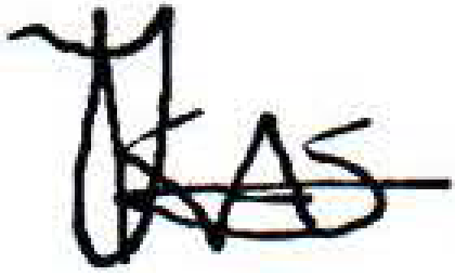

Thomas Holeinge Kasita Registrar of the High Court Main Division

Windhoek

TO:
ERICK MOYO

AND TO:
On behalf of 1s t Appellant
Government - Office of the Prosecutor-General High Court Building Luderitz Street
Windhoek Namibia Namibia

Johannes Ludwig Burger Respondent

AND TO:
Windhoek Central{Mungunda)(Magistrate Court)

