REPUBLIC OF NAMIBIA
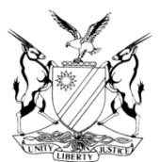
IN THE HIGH COURT OF NAMIBIA, NORTHERN LOCAL DIVISION, OSHAKATI
REVIEW JUDGMENT

Case Title:  The State v Nghinandjo Mingeli | CR No.: 06/2020  Case No.: 168/2016
Division of Court:
Northern Local Division
Heard before:  Honourable Mr Justice January J et  Honourable Ms Justice Salionga AJ | Delivered on:  29 January 2020
Neutral citation: S v Mingeli (CR 6/2020) [2020] NAHCNLD 13 (29 January 2020)

The order:
- The conviction of assault with intent to do grievous bodily harm is confirmed;

- The sentence of N$2000 or one (1) year in default is corrected to N$2000 or one (1) year imprisonment in default of payment.

Reasons for the order:

[1] The sentence of N$2000 or one (1) year in default is incomplete and does not make much sense.
H C JANUARY  JUDGE |  | J T SALIONGA  JUDGE

